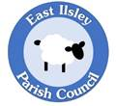
Annual Parish Meeting East Ilsley Parish Council
12th May 2026 19:30 The Ilsleys primary School

- Welcome and introduction by the Chair
- Chair’s annual report
- Financial report from the Clerk
- Reports from -
  - Carolyne Culver
  - The Working Party
  - Reverend Nicola Hulks from St Marys Church
  - Statement from Mrs House on updates for the primary School
- Matters raised by electors
- Open discussion
- Close

Signed

Date

